Information
about the
Use and Care
of the
UUCF Program Building

Please read before your event.
Emergency Information
For Building Emergencies After Hours, Call:
540-560-8845
Emergency Contact Information

Emergency Police, Fire, Ambulance
9-1-1

Poison Control
1-800-222-1222

Non-Emergency Police/Fire
703-691-2131

Fairfax County Government Emergency Info
703-817-7771

UUCF Executive Director
703-281-4230, ext. 222 office/540-560-8845 after hours

Fairfax County Help Line (Use after natural disasters)
2-1-1
UU Trauma Team: www.traumaministry.org
866-730-8181
Utilities

Power
Dominion Virginia Power
888-667-3000
Representatives available Mon-Fri. 7 a.m. to 7 p.m.,
Sat. 9 a.m. to 1 p.m.
Automated recording system all other times.
Gas Leak
Washington Gas
703-750-1400 or 800-752-7520
Water
Fairfax County Water Authority
703-689-5800

Sewer Breaks or Back-ups
Department of Public Works and Environmental Services
703-323-1211 or 703-250-2003

Cleaning New Chairs and Sofas
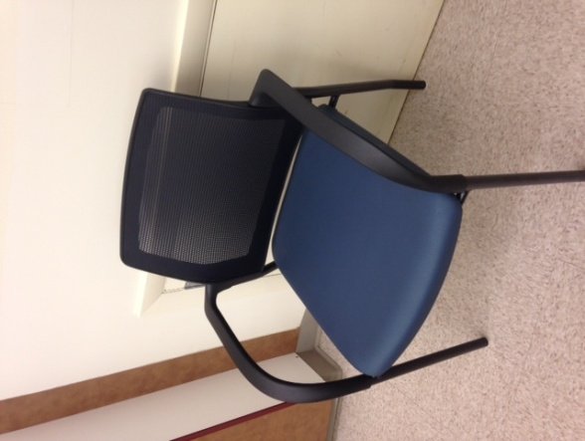
Immediately, after any spill:
- Spot Clean
Use a dampened white cloth and the spray found in a basket in each of the rooms with new soft seating.
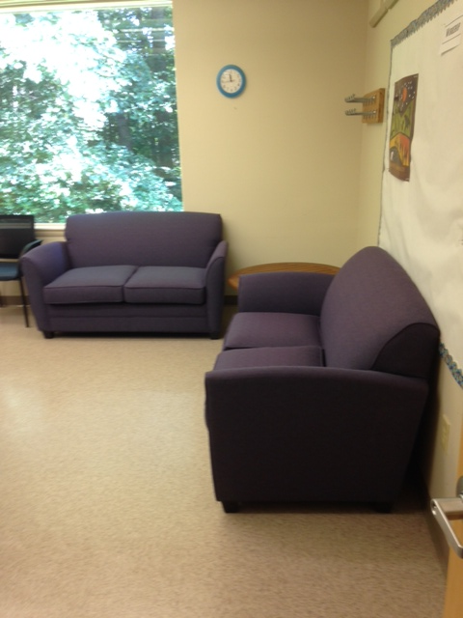
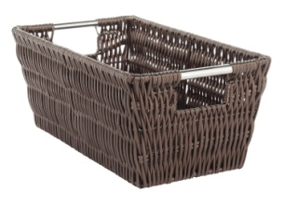

- Report all spills to uucf@uucf.org.
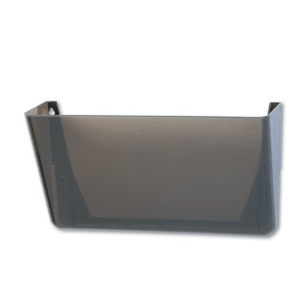
You may also leave a note in the door holder (no tape!) identifying the type of spill and location so that UUCF staff can clean further.
Kitchen in Lobby
One Coffee Urn per Electrical Outlet
Our outlets only power one large coffee urn per outlet. Once the coffee urn begins brewing, it will draw too much electricity and overload the circuit. Please use a separate outlet for each coffee or hot water urn.
Use Recycle Bins
We recycle! Please use the blue bins for recycling and the other bins for trash. Renters must bag the trash and take to the parking lot dumpsters.
Copier
Copier is for UUCF staff and member use only. Extra paper can be procured from the office during regular business hours.
Lights
Please turn the lights off when you leave!
NO TAPE
Please do not tape or adhere posters or signs to cabinets, walls, windows or doors. Use the sign holders on the doors or bring plastic standing sign holders for your event. Your event is listed, with time and place, on the front door of the Program Building.
Social Hall and Kitchen
Lights
The fluorescent lamps controlled by the dimmer take several minutes to reach full brightness. Please be patient. Turn off lights when you leave, including in the Social Hall lobby.
One Coffee Urn per Electrical Outlet
Our outlets only power one large coffee urn per outlet for brewing. Please use a separate outlet for each coffee urn.
Freezer Doors
Please check freezer and refrigerator doors to make sure they are firmly closed before leaving the kitchen area.
Return and Dispose of All Items Properly
Use the photos on the cabinets or the labels inside each cabinet to return clean and dry items to the cabinets. Place soiled UUCF linens on the cart in the lobby. Renters must bag the trash (not the recycling) and bring to the parking lot dumpsters. Please replace with fresh trash bags, found in the drawers.

Food
Please take all food and beverages home with you, or deliver to one of the shelters listed below. Pour out any beer or wine. Do not leave any alcohol in the UUCF kitchen.

Please call before delivering leftover food:

Katherine K. Hanley Family Shelter (Fairfax)
1300 Lee Highway, Fairfax, VA 22030
(actually faces Metal Estates Drive if driving there)
Will not accept pork products or food containing peanuts
Staff is there to accept food 8 a.m. to 9 p.m. (2-2014)
571-522-6800; FAX 703-988-0251; TTY 703-988-0256

Embry Rucker Community Shelter (Reston)
11975 Bowman Towne Drive, Reston, VA 20190
703-437-1975; Fax 703-481-1406
Can deliver there 24 hours a day. (2-2014)
No food restrictions.

DO NOT
COOK
GREASE-LADEN
FOODS

