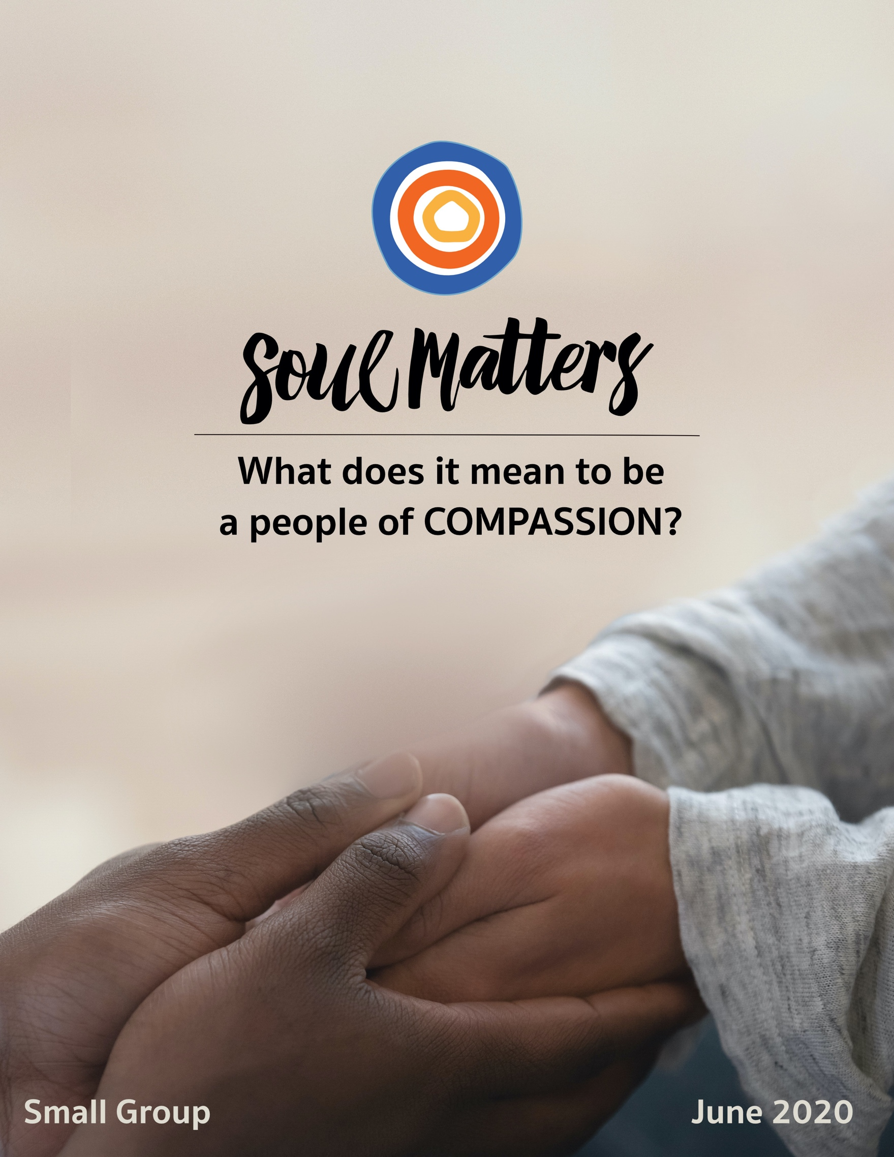

What Does It Mean To Be
A People of Compassion?

It might seem like one of our easier monthly themes. After all, compassion sounds…well, nice. It conjures up a bunch of warm feelings. Images come to mind of people telling each other they are keeping them in their thoughts. It would seem to be all about emotional connection and empathetic feeling.

But then along comes a quote like this:

“Compassion hurts. When you feel connected to everything, you also feel responsible for everything. And you cannot turn away. Your destiny is bound with the destinies of others.” -Andrew Boyd

Or this:

“True compassion is to engage in the suffering of others.”
- The Charter for Compassion

Both are reminders that compassion is not just a matter of niceness and thoughtful feelings. It’s a deeper type of feeling that drives us to action.

Indeed, that may be compassion’s defining characteristic; it is distinguished by doing. To feel the pain of another, well, the word “empathy” has that covered. But compassion takes it a step further. Compassion calls us to do something about that pain.

In other words, compassion calls us to change things! It’s not just about comforting others; it’s about our comfort getting disturbed. It’s about connecting with another’s pain and struggle so deeply that we can’t rest until they rest. When we feel compassion - real compassion - we don’t just understand another’s pain, we want it to stop. And then we do what’s needed to make it stop.

It makes one wonder: Maybe the true test of compassion is justice.

And if that’s close to the mark, then maybe compassion’s question for us this month isn’t what we thought it was. Instead of asking us, “Are you able to feel?” maybe it’s asking, “What are you prepared to do?

Our Spiritual Exercises

Option A

Guerilla Compassion

During this time of Covid-19, suffering and struggle are ubiquitous. Whether it comes in the form of sickness and job loss or loneliness, stress and worry, suffering has taken up residence in so many of our homes. Compassion is needed now more than ever. And yet because of social isolation, it’s harder than ever for us to extend our kindness and care to those who need it.

Or is it?

There are always creative, irregular and even sneaky ways to offer our compassion to others, to let them know they are seen and not alone. You might even call it “guerilla compassion.” Imagine leaving an unexpected vase of flowers on a neighbor’s porch to brighten their day. Or stealthily going to the house of a neighbor who’s been sick and surprising them with a pre-dawn weeding of their flower bed. What about sending a random “You Rock!” note to your child’s teacher who is doing their best to learn new online ways of teaching for the sake of your kid and so many others? Are you a photographer? How about inviting folks on your block to step outside their front door for a family portrait with their home that has now become their entire world? (It might at least get people to shower and get out of their pajamas!) Or maybe it’s organizing a flash mob-like carpool that drives over and sings Happy Birthday, Happy Anniversary or Happy Graduation to that person who’s been cheated out of a real celebration.

All of these things can be done while honoring social distancing. None of them require the removal of our masks. All it takes is some creativity and guerilla tactics.

So, what will your act of “guerilla compassion” be?

(For some inspiration, watch THIS, THIS & THIS)

Option B

Meditate Your Way into Compassion

For many, meditation and compassion go hand in hand. The Buddhist practice of metta meditation (also known as loving-kindness meditation) is a particularly powerful way of directing compassion toward yourself, others close to you and all beings everywhere. Compassion is also a central theme in the prayer and meditation practices of all religious traditions. Common to them all is the idea that bringing others to mind in a compassionate way and with kind intent makes a difference. Just the intention, even without any direct interaction. One can debate whether it makes a difference for others or just ourselves, but as any committed meditation practitioner will tell you, once you’ve been changed, you change the way you treat others. Once your internal mental frame for others change, so do your outward actions.

So this exercise invites you to give it a try this month: Use a compassion-related meditation practice and see what changes it brings.

Below are some resources to help you try out the Buddhist metta meditation (loving kindness meditation). But we’ve also included a song and video to support some self-care meditation/reflection. Don’t overthink it or pressure yourself to do meditation “the right way.” Just set aside some time each day for at least a week and monitor the impact it has on your living and loving.

Metta Meditation Resources
- What is Metta Meditation?
https://tricycle.org/magazine/metta-practice/
- Loving-Kindness Meditation for Beginners
https://lotusheartmindfulness.com/lotus-heart-blog/2020/3/2/loving-kindness-meditation-for-beginners
- Extended Loving-Kindness Meditation - Video
https://www.youtube.com/watch?v=auS1HtAz6Bs
- Text Instructions for Metta Meditation
http://www.beliefnet.com/Health/2000/07/Opening-The-Heart.aspx

Musical Meditation on Grief and Self-Care - Loosen, Loosen by Aly Halpert
https://soundcloud.com/aly-halpert/loosen-loosen?fbclid=IwAR3scFP1MPfBXTBGuIugutlRBuC1lcX6p5pxMcfhpvAV6j60jEqHFCvV6RU
Also: https://www.youtube.com/watch?v=l5ydfADtn7Q

A Self-Compassion Exercise
https://www.youtube.com/watch?time_continue=89&v=-kfUE41-JFw

Option C

Morning Metta on Your Mirror!

If you’re not the meditating type and the Option B exercise just isn’t your cup of tea, don’t worry, you don’t have to give up entirely on exploring the impact of loving-kindness. All this exercise asks you to do is tape the metta/loving-kindness mantra on your bathroom mirror and give it some thought while you brush your teeth! And of course you are free to improvise: taping it on your coffee machine or writing it on 3*5 card that you read while eating your morning cereal works just as well.

Here are some versions of the traditional metta phrases:
- May (I/you/all) live in safety, be happy, be healthy, live with ease.
- May (I/you/all) be safe and protected. May (I/you/all) be healthy and strong. May(I/you/all) be truly happy.
- May (I/you/all) be free from danger. May I have mental happiness. May I have physical happiness. May I have ease of well-being
Whichever wording you pick, use it to direct compassion into wider and wider circles of relationship: yourself, someone you love, someone you are neutral towards, someone you have difficulty with and finally toward all beings everywhere.

In other words, begin your day by simply calling to mind these various relationships and wishing them well. It’s a whole lot better than beginning your day thinking about that challenging co-worker of yours and imagining all the ways you hope they get “what they deserve.” Actually, that is kind of the point: When we intentionally reframe our relationships and tell ourselves what everyone deserves is compassion, it changes the way we see them, and it changes us.

Option D

A Little Compassion for Yourself

Most of our exercises invite us to direct our compassion toward others. But, compassion toward others just doesn’t work unless we’re able to offer it to ourselves. And the truth is we’re not always good at doing that. So this month, why not get a little better?
Self-Compassion by Counting Up Everything That’s on Your Plate
Don’t be fooled by the simplicity of this exercise. The power of it often isn’t apparent until you’re halfway through.

Set aside an evening. Make sure to wall off a good hour where you know you won’t be interrupted by anyone. Take the mood seriously; turn on a favorite piece of music and pour a cup or glass of your favorite drink. Then pull out a pen and one sheet of paper. And spend the next 30 minutes writing down everything that is “on your plate.” Every responsibility. Every worry. Every source of stress. Every challenge. Every one that depends on you right now. Trust us; it will take at least 30 minutes. There is hardly anyone who’s load is light. Even if you think your's is, you’ll quickly realize it’s not.

And that’s exactly the point. Somewhere between #9 and #14 on your list, you will say to yourself, “My God I’m carrying a lot!” And it will be right then that compassion for yourself will start to set in. Keep going. Keep adding to the list. As you do, it will become more than apparent - to your heart, not just your head - that you’re not just deserving of compassion but also admiration. That’s right, there will be this moment when you finally allow yourself to be surprised at how well you are handling things. It will make all those perfectionist, self-punishing voices in your head seem just plain silly. Let yourself feel that. And in that moment, make yourself say something out loud to yourself. Tell yourself exactly the compassionate thing you would say to a friend whose list is as long as yours.

Option E

Wrestle with Your Niceness

There’s wide agreement that compassion plays a role in fighting racial injustice and dismantling white supremacy, but it’s also true that there’s nothing simple about that relationship between compassion and racial justice. One everyday example of this is the way niceness is used to mask, perpetuate and even defend one’s unacknowledged racism. For writer and anti-racism coach, Robin diAngelo, one small but important step in dismantling white supremacy is getting clear about the many ways we conflate and confuse niceness with compassion. So as your exercise this month, spend some time with diAngelo’s article and use it to offer yourself some challenge and compassion as you bring awareness to your own habits of “problematic niceness.”

White People Assume Niceness Is The Answer To Racial Inequality. It's Not, Robin diAngelo
https://www.theguardian.com/commentisfree/2019/jan/16/racial-inequality-niceness-white-people

Dig Deeper: At the recent MidAmerica Regional Assembly, Taquiena Boston, Special Advisor the UUA President on Equity, Inclusion, and Change, offered a number of questions to help support decentering work during Covid-19. Here are two for you to spend some time with:
- Who or what are you holding in your heart at this moment?
- What inequities have become more visible to you as a result of COVID-19?

Option F

Find Compassion in Our Recommended Resources

Our recommended resources are full of wisdom about what it means to be a people of and a person of compassion. Engaging these resources and finding the one that especially speaks to you is a spiritual practice in and of itself.

So, if none of the above exercises call to you, engage the recommended resources section of this packet as your spiritual exercise for the month.

Set aside some regular time throughout a week to go through them and meditate on them until you find the one that most expands or deepens your understanding of compassion. After you’ve found it, consider printing it out and carrying it with you or pinning it up so you can continue to reflect on it throughout the weeks leading up to your group meeting. Come to your group ready to share where the journey led you.

Your Question

Don’t treat these questions like “homework” or try to answer every single one. Instead, make time to meditate on the list and then pick the one question that speaks to you most. The goal is to figure out which question is “yours.” Which question captures the call of your inner voice? Which one contains “your work”? What is that question trying to get you to notice or acknowledge?

Often it helps to read the list to a friend or loved one and ask them which question they think is the question you need to wrestle with!

- What did your family of origin teach you about compassion? Who deserved compassion? Who didn’t? What did it mean? Tenderness? Tough love? Being moved to action?

- What do you know now about compassion that you didn’t know at 18 years old?

- What was your primary self-care and self-compassion strategy as a child and then as a teenager? Is there a lesson/call/reminder in that for you today?

- Who taught you an entirely different way of imagining compassion?

- When were you healed by the compassion of a stranger?

- When were you healed by the compassion of an animal?

- When were you healed by the compassion of nature?

- When were you healed by “compassionate art”?

- Have you ever been healed by the compassion of God?

- Who’s that person in your life that doesn’t deserve compassion? Are you sure?

- If asked, would your family members say you are good at being compassionate with yourself?

- Is it possible that you are suffering from the subtle aggression of self-improvement?

- Is compassion about protection from suffering or opening to it?

- What if empathy does not require exoneration?

- What if the true test of compassion is justice?

- Is it possible you are suffering from compassion fatigue? Is taking on the pain of others taking a toll on you?

- Do you believe compassion is contagious?

- What’s your question? Your question may not be listed above. As always, if the above questions don't include what life is asking from you, spend the month listening to your days to hear it. Or maybe the question or call you need to hear is waiting in one of the quotes listed below. Consider looking there!

Companion Pieces

Recommended Resources for Personal Exploration & Reflection

The following resources are not required reading. We will not analyze these pieces in our group. Instead they are here to companion you on your journey this month, get you thinking and open you up to new ways of thinking about what it means to be part of a people of compassion.

Word Roots & Definitions

Compassion is the heart’s response to suffering. Compassion — from the roots passio (suffering) and com (with) — means to suffer with another. Compassion is an innate part of human response to suffering, which is comprised of a three-part experience of noticing another’s pain, feeling with another, and responding in some way.
Source

Compassion [is] concern to enhance the welfare of another who suffers or is in need. This is different from empathy, which is the "mirroring or understanding of another's emotion." So empathy is feeling; compassion is action.
Jeremy Smith

Wise Words

The value of compassion cannot be over-emphasized. Anyone can criticize. It takes a true believer to be compassionate. No greater burden can be borne by an individual than to know no one cares or understands.
Arthur H. Stainback

It is in compassion that we feel most at home and feel most whole. We feel that we are where we should be.
Ingrid Mattson

If your compassion does not include yourself, it is incomplete.
Jack Kornfield

The judged self can only be judged but not known.
Adam Phillips

The time will come
when, with elation
you will greet yourself arriving
at your own door, in your own mirror
and each will smile at the other's welcome
Derek Walcott

Don’t meditate to fix yourself, to improve yourself, to redeem yourself; rather, do it as an act of love, of deep warm friendship to yourself. In this way there is no longer any need for the subtle aggression of self-improvement, for the endless guilt of not doing enough. It offers the possibility of an end to the ceaseless round of trying so hard that wraps so many people’s lives in a knot.
Bob Sharples

The curious paradox is that when I accept myself as I am, then I can change.
Carl Rogers

We must remember that if we are to give compassion to others, we must first be compassionate with ourselves. Today, I urge you to take a moment, notice your breath, and search your depths. Is there anything about yourself–a failure, an insecurity, a bad habit, a negative emotion–for which you are very hard on yourself? When you find that thing, say the following words. I will use ‘anger’ for the example, but insert your own hang-up:
“I see my anger. I care about my anger. I desire an end to my anger. May I hold my anger with tenderness.”
Terence Stone

Enough
Danna Faulds
Full poem at http://shreeyogathemes.blogspot.com/2015/03/enough-is-enough.html

It's enough to be
and breathe, to feel the
touch of wind on the skin.
It's enough to take the
day as it comes…
It's enough to
be buffeted by the winds
of change and not blown
over. I and you and all
of us, more than enough.

Were we to meet this figure socially, as it were, this accusatory character, this internal critic, we would think there was something wrong with him. He would just be boring and cruel. We might think that something terrible had happened to him. That he was living in the aftermath, in the fallout of some catastrophe. And we would be right.
Adam Phillips

A great deal of chaos in the world occurs because people don’t appreciate themselves. Having never developed sympathy or gentleness toward themselves, they cannot experience harmony or peace within themselves, and therefore, what they project to others is also inharmonious and confused.
Chogyam Trungpa

There appears to be a vast amount of confusion on this point, but I do not know many Negroes who are eager to be “accepted” by white people, still less to be loved by them; they, the blacks, simply don’t wish to be beaten over the head by the whites every instant of our brief passage on this planet. White people in this country will have quite enough to do in learning how to accept and love themselves and each other, and when they have achieved this — which will not be tomorrow and will not be today and may very well be never — the Negro problem will no longer exist, for it will no longer be needed.
James Baldwin, The Fire Next Time

I still believe that having compassion for others is not the same as saying that the harm they cause is ok. Empathy is not exoneration.
Nadia Bolz-Weber

Compassion is not a relationship between the healer and the wounded. It’s a relationship between equals. Only when we know our own darkness well can we be present with the darkness of others. Compassion becomes real when we recognize our shared humanity.
Pema Chödrön

How far you go in life depends on your being tender with the young, compassionate with the aged, sympathetic with the striving, and tolerant of the weak and strong. Because someday in life you will have been all of these.
George Washington Carver

The whole idea of compassion is based on a keen awareness of the interdependence of all these living beings, which are all part of one another and all involved in one another.
Thomas Merton

Compassion allows us to use our own pain and the pain of others as a vehicle for connection.
Sharon Salzberg in The Kindness Handbook

For me, compassion usually means being able to see myself in others, my weakness or fear, my humanity.
adrienne maree brown

The purpose of the journey is compassion. When you have come past all the pairs of opposites you have reached compassion.
Joseph Campbell

Unless we are very, very careful, we doom each other by holding onto images of one another based on preconceptions that are in turn based on indifference to what is other than ourselves. This indifference can be, in its extreme, a form of murder and seems to me a rather common phenomenon. We claim autonomy for ourselves and forget that in so doing we can fall into the tyranny of defining other people as we would like them to be. By focusing on what we choose to acknowledge in them, we impose an insidious control on them. I notice that I have to pay careful attention in order to listen to others with an openness that allows them to be as they are, or as they think themselves to be. The shutters of my mind habitually flip open and click shut, and these little snaps form into patterns I arrange for myself. The opposite of this inattention is love, is the honoring of others in a way that grants them the grace of their own autonomy and allows mutual discovery.
Anne Truitt

Compassion doesn’t mean feeling sorry for people. It doesn’t mean pity. It means putting yourself in the position of the other, learning about the other, learning what’s motivating the other, learning about their grievances... their pain, their humanity.
Karen Armstrong

Compassion has been advocated by all the great faiths because it has been found to be the safest and surest means of attaining enlightenment. It dethrones the ego from the center of our lives and puts others there, breaking down the carapace of the selfishness that holds us back from an experience of the sacred. And it gives us ecstasy, broadening our perspectives and giving us a larger, enhanced vision.
Karen Armstrong in The Spiral Staircase
Compassion asks us to go where it hurts, to enter into the places of pain, to share in brokenness, fear, confusion, and anguish. Compassion challenges us to cry out with those in misery, to mourn with those who are lonely, to weep with those in tears. Compassion requires us to be weak with the weak, vulnerable with the vulnerable, and powerless with the powerless. Compassion means full immersion in the condition of being human.
Henri J.M. Nouwen

We are called to be enlightened witnesses: people who through their kindness, tenderness and attentive love, return people to themselves.
Alice Miller

Your acts of kindness
are iridescent wings
of divine love
which linger and continue
to uplift others
long after your sharing
Rumi

Shoulders
Naomi Shihab Nye
Full poem at https://poets.org/poem/shoulders
Spoken: https://www.youtube.com/watch?v=thaNhao7aLg

In all this madness, even if it kills every single one of us and there’s no one left to tell the stories, it matters that we love each other well.
Paul Richards, who died of AIDS, as remembered by Rev. Kim Crawford Harvie

Please Call Me By My True Names
Thich Nhat Hanh
https://www.filmsforaction.org/articles/thich-nhat-hanh-call-me-by-my-true-names/

Have compassion for everyone you meet, for you do not know what wars are going on down there, where the spirit meets the bone.
Lucinda Williams

don’t you wish you were
the sun and could wrap your arms
around everyone
John Paul Lederach

Music

We create two different playlists for each of our monthly themes: one in Spotify and another in YouTube. We organize these lists as a journey of sorts. So consider listening from beginning to end and using the lists as musical meditations. Follow the links below to connect with this month’s “ threshold songs.”

Click here for the Spotify playlist on Compassion.
Click here for all Spotify playlists.
Click here for the YouTube playlist on Compassion.
Click here for all the YouTube playlists.

Videos & Podcasts

Reimagining Compassion as Power
https://www.youtube.com/watch?v=E_guy-i2BTE
A call to rethink compassion not as feelings of warmth and kindness but as a set of impactful practices and skills.

Where Does Compassion Really Come From?
https://www.youtube.com/watch?time_continue=21&v=A4a66aFaIME&feature=emb_logo
Compassion begins with attention!

What’s the Difference Between Sympathy, Empathy Altruism and Compassion?
https://www.youtube.com/watch?v=35Wt8LhoVHA

A Self-Compassion Exercise
https://www.youtube.com/watch?time_continue=89&v=-kfUE41-JFw

Socially Distanced Street Parade Greets Teenager after Cancer Treatment
https://www.youtube.com/watch?v=_5ca2vBGTFw&fbclid=IwAR3Np8VlryAZtUGO8C3Xy7cAZoRerYScQ7MOtSqygK-s-fff6Q1cEMMSajU

Musical Meditation on Grief and Self-Care - Loosen, Loosen by Aly Halpert
https://soundcloud.com/aly-halpert/loosen-loosen?fbclid=IwAR3scFP1MPfBXTBGuIugutlRBuC1lcX6p5pxMcfhpvAV6j60jEqHFCvV6RU
Also: https://www.youtube.com/watch?v=l5ydfADtn7Q
Articles

Covid-19, Compassion & Racism (3 articles & a video discussion)
- https://www.theatlantic.com/ideas/archive/2020/04/stop-looking-away-race-covid-19-victims/609250/
- https://www.theguardian.com/world/2020/apr/08/its-a-racial-justice-issue-black-americans-are-dying-in-greater-numbers-from-covid-19
- https://www.motherjones.com/coronavirus-updates/2020/04/black-people-are-dying-from-covid-19-at-higher-rates-because-racism-is-a-pre-existing-condition/
- https://www.facebook.com/watch/live/?v=532120480829118&ref=watch_permalink

Creating Racial Justice Through Compassion And Self-awareness (2 articles)
- https://greatergood.berkeley.edu/article/item/how_to_fight_racism_through_inner_work
- https://lindagraham-mft.net/creating-racial-justice-through-compassion-and-self-awareness/

White People Assume Niceness Is The Answer To Racial Inequality. It's Not
https://www.theguardian.com/commentisfree/2019/jan/16/racial-inequality-niceness-white-people

Compassionate Warrior Bootcamp for White Allies
https://www.whiteallytoolkit.com/digital-publications/compassionate-warrior-bootcamp-for-white-allies-digital-pdf-version

Understanding the Limits of Human Compassion
https://www.vox.com/explainers/2017/7/19/15925506/psychic-numbing-paul-slovic-apathy

Does Wealth Reduce Compassion?
https://www.scientificamerican.com/article/how-wealth-reduces-compassion/
https://greatergood.berkeley.edu/article/item/does_wealth_reduce_compassion

Compassion Made Easy: On the Science of Compassion
https://www.nytimes.com/2012/07/15/opinion/sunday/the-science-of-compassion.html

The Recipe for Happiness and Success? Try Compassion
https://www.cnn.com/2017/04/12/health/compassion-happiness-training/index.html

Mindfulness Apps & Self-Care/Compassion
https://www.npr.org/sections/health-shots/2017/10/16/557633144/mindfulness-apps-aim-to-help-people-disconnect-from-stress

Books
- Against Empathy: The Case for Rational Compassion, Pal Bloom
- The Compassion Book: Teachings for Awakening the Heart, Pema Chödrön
- Twelve Steps to a Compassionate Life, Karen Armstrong
- The Inner Work of Racial Justice, Rhonda V. Magee
- Real Love, Sharon Salzberg
- Self-Compassion: The Proven Power of Being Kind to Yourself, Kristin Neff

Movies

Won’t You Be My Neighbor?
50/50
Shoplifters
Roma
Amélie
Up
The Fisher King
Wit

More Monthly Inspiration from Soul Matters!

Our Facebook Inspiration Page:
https://www.facebook.com/soulmatterssharingcircle/

Our Instagram Page:
Find us as “soul_matters_circle”

Music Playlists:
Click here for links to the Spotify playlists for each month.
Click here to check out the YouTube playlists.

Find support for bringing the
monthly themes home and into your family life with
Soulful Home: A Guide for Families:
https://www.soulmatterssharingcircle.com/soulful-home.html

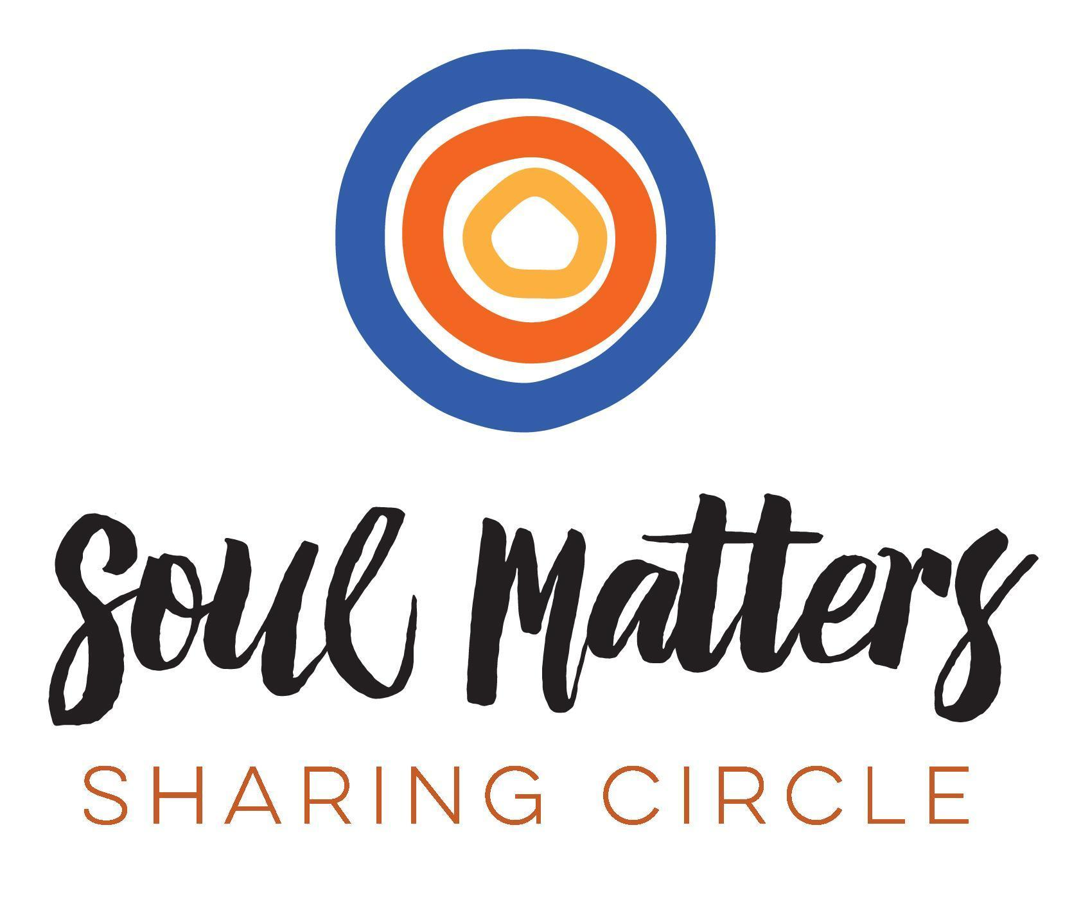
© 2019-20 Soul Matters ALL RIGHTS RESERVED

Packets are for use only by member congregations of the Soul Matters Sharing Circle.
Learn how to join at
https://www.soulmatterssharingcircle.com

